Exercise 1. Look , read and tick () or cross (×) :
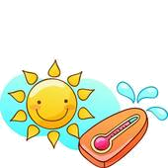
It's sunny.
It's snowing.
It's windy .
It's raining .

It's hot.
It's windy.

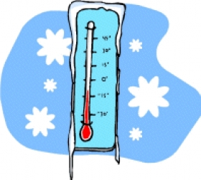
It's raining.
It's sunny.
It's raining.
It's cold.
It's windy .
It's raining.

Exercise 2 Look at the table above and write sentences , as in the example :
Monday | Tuesday | Wednesday | Thursday | Friday | Saturday | Sunday
a) How’s the weather on Monday ?
…………………………………………………………….
b) How’s the weather on Tuesday?
…………………………………………………………….
c) How’s the weather on Friday?
…………………………………………………………….
d) How’s the weather on Sunday ?
…………………………………………………………….
e) How’s the weather on Thursday?
…………………………………………………………….
Exercise 3 Read and match :
1. It’s cold. | a .Don’t put on your coat.
2. It’s windy. | b. Fly a kite .
3. It’s hot . | c. Make a snowman.
4. It’s raining. | d. Don’t forget your umbrella.
5. It’s snowing. | e. Wear a sun hat.
6. It’s sunny. | f. Wear a coat.

Exercise 4. Complete the sentences :
fly a kite go swimming play in the park watch TV

a. I can _______________________when it is hot.
b. I can _______________________when it is windy.
c. I can _______________________when it is sunny.
d. I can _______________________when it is raining.

